COVID-19 Vaccine Management System
Design Document

Version 1.0



Group Id: S2102A3CF0
Supervisor Name : Hina Ishaq

Revision History
Date (dd/mm/yyyy) | Version | Description | Author
21/06/2021 | 1.0 | This project is all about managing the successful distribution of COVID-19 Vaccines nationwide by a web-based interface. This system will provide users and admins specific interfaces to interact with it. This is going to be the first version i.e. 1.0 of the system, and this document will include details about followings:  - Introduction of Design Document  - Entity Relationship Diagram (ERD)  - Sequence Diagrams  - Architecture Design Diagram  - Class Diagram  - Database Design  - Interface Design  - Test Cases | Hamza Ashraf (BS170400637)

Table of Contents

- Introduction of Design Document
- Entity Relationship Diagram (ERD)
- Sequence Diagrams
- Architecture Design Diagram
- Class Diagram
- Database Design
- Interface Design
- Test Cases

- Introduction of Design Document
Software Design Document is often referred as Software Design Specification. This document contains the detailed plan that is to be followed in order to design either a piece of software or a complex project. Software design document should contain the functionalities of end product in such a way that reader after reading this document can have a clear idea of what is going to be built. It is better to have a design document before jumping in to the coding phase.
Having a well written design document could reduce any potential ambiguities in the system and its design. All stakeholders of the project including coders, testers, designers and end users can have same expectations from the system. Moreover, design document can streamline the coding phase as everything is pre-planned.
For this project titled “Covid-19 Vaccine Management System” this design document will contain followings:
- Entity Relationship Diagram (ERD)
- Sequence Diagrams
- Architecture Design Diagram
- Class Diagram
- Database Design
- Interface Design
- Test Cases
- Entity Relationship Diagram (ERD) (To be developed using Microsoft Visio or any other drawing software of your choice)
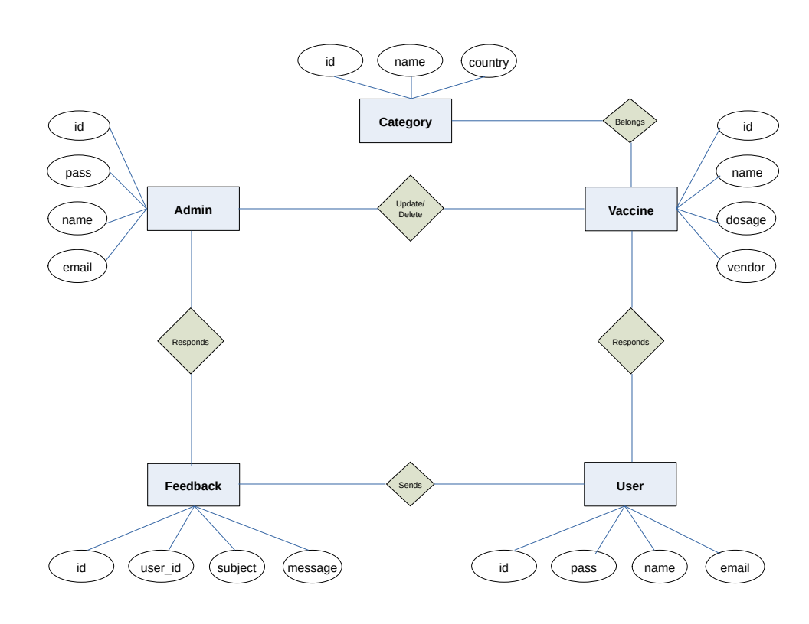
- Sequence Diagrams (To be developed using Rational Rose or any other drawing software of your choice)
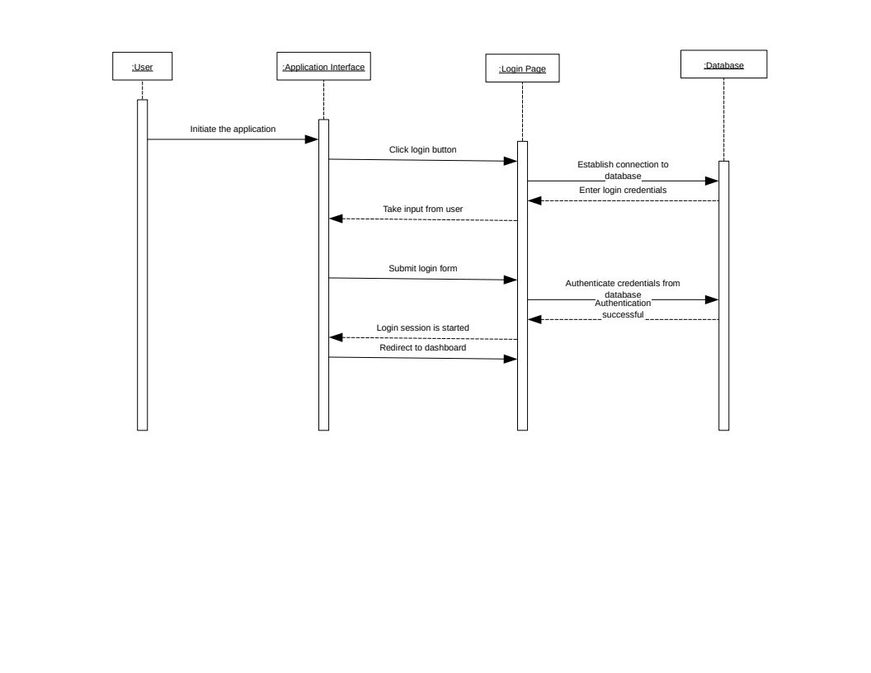Figure 1: Login - Sequence Diagram

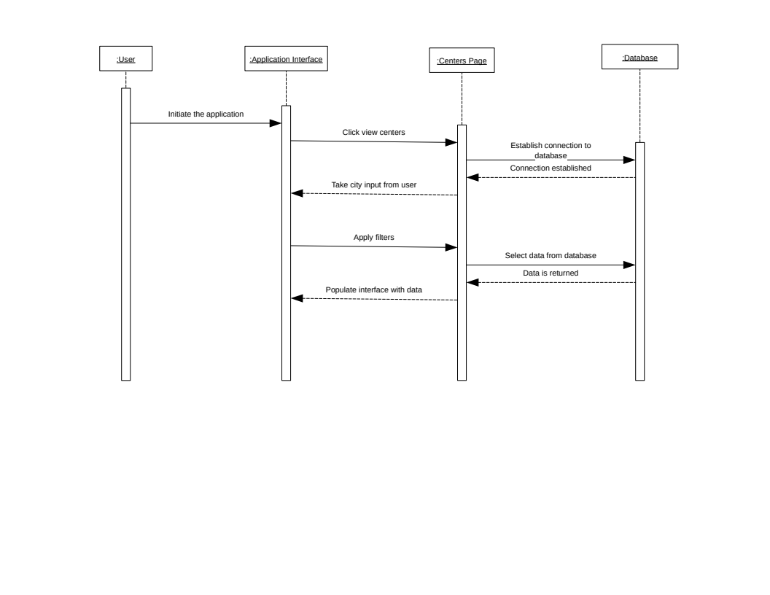Figure 2: View Centers - Sequence Diagram

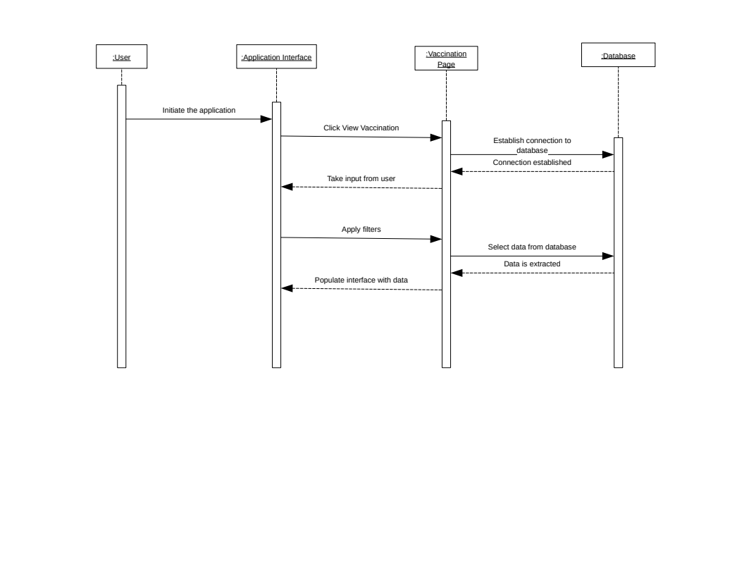Figure 3: View Vaccination - Sequence Diagram

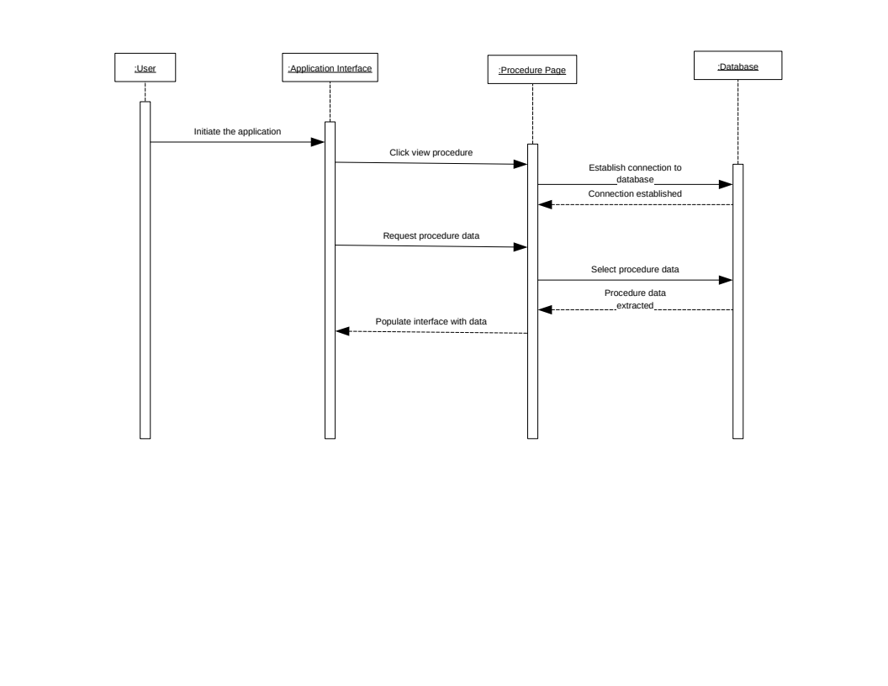Figure 4: View Procedure - Sequence Diagram
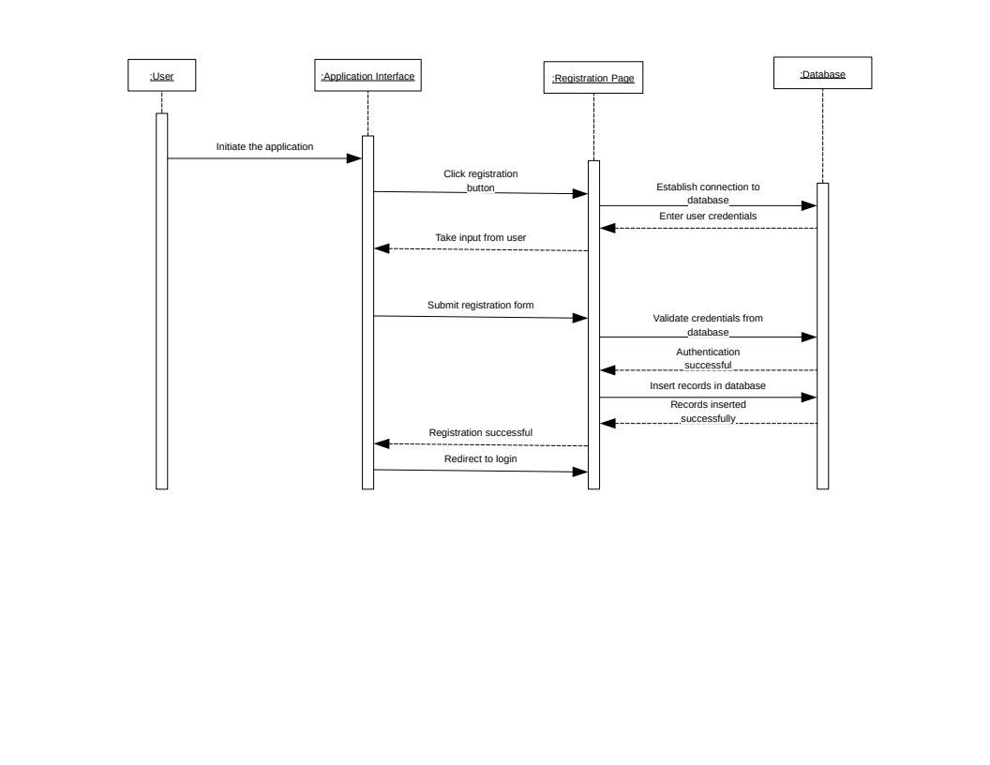Figure 5: User Registration - Sequence Diagram
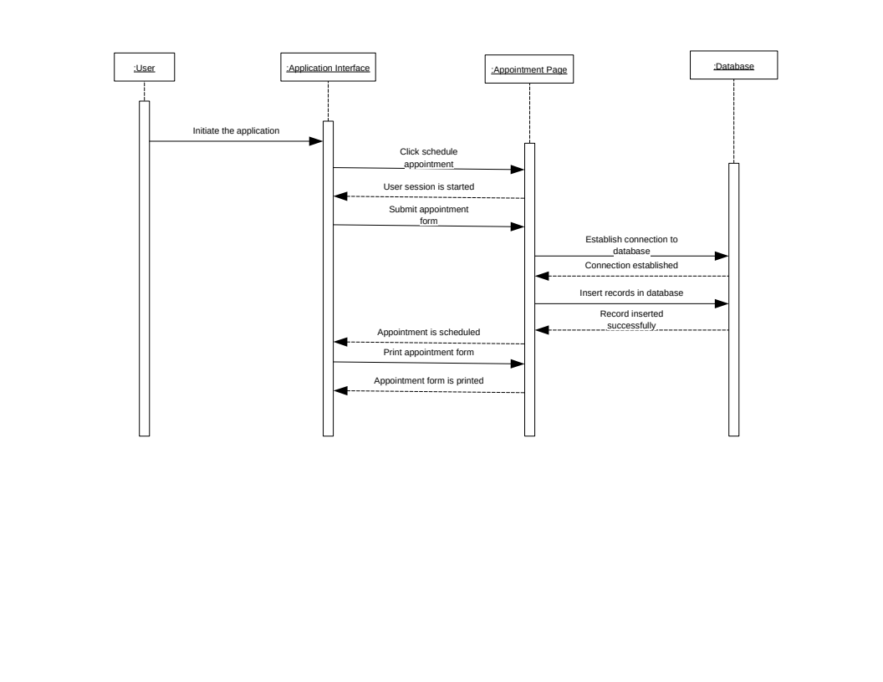Figure 6: Schedule an Appointment - Sequence Diagram

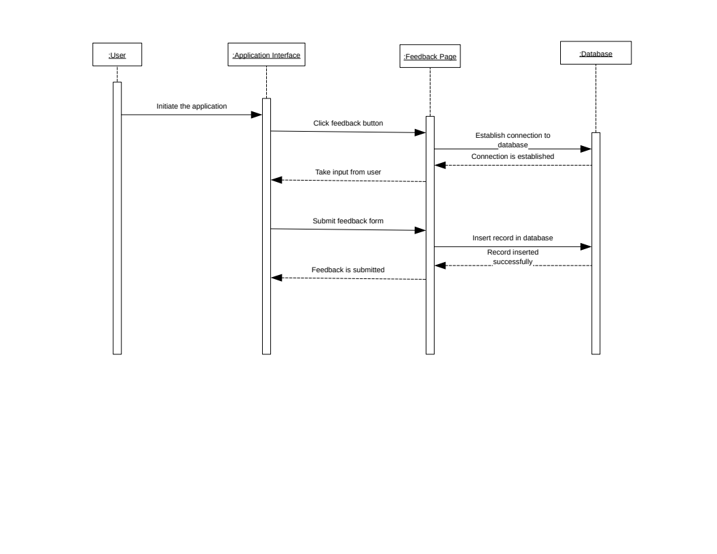Figure 7: Submit Feedback - Sequence Diagram

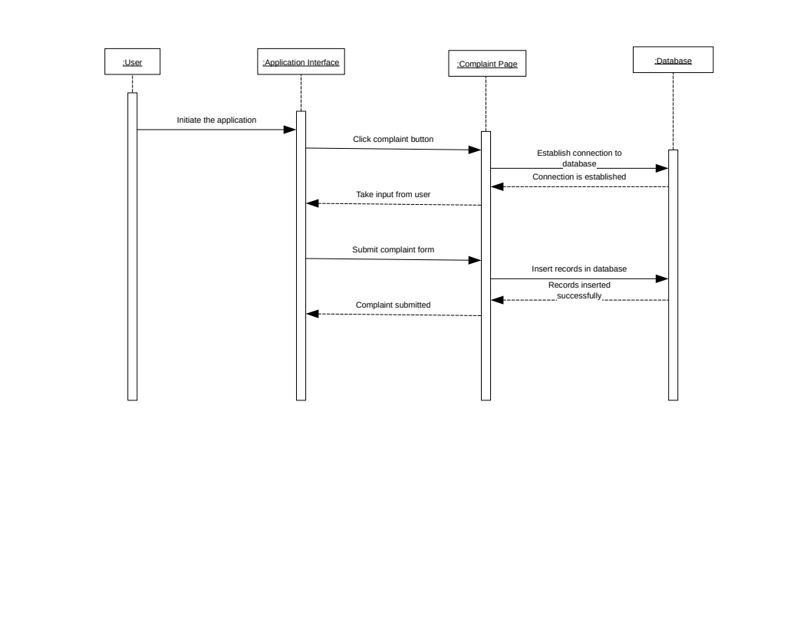Figure 8: Register a Complaint - Sequence Diagram

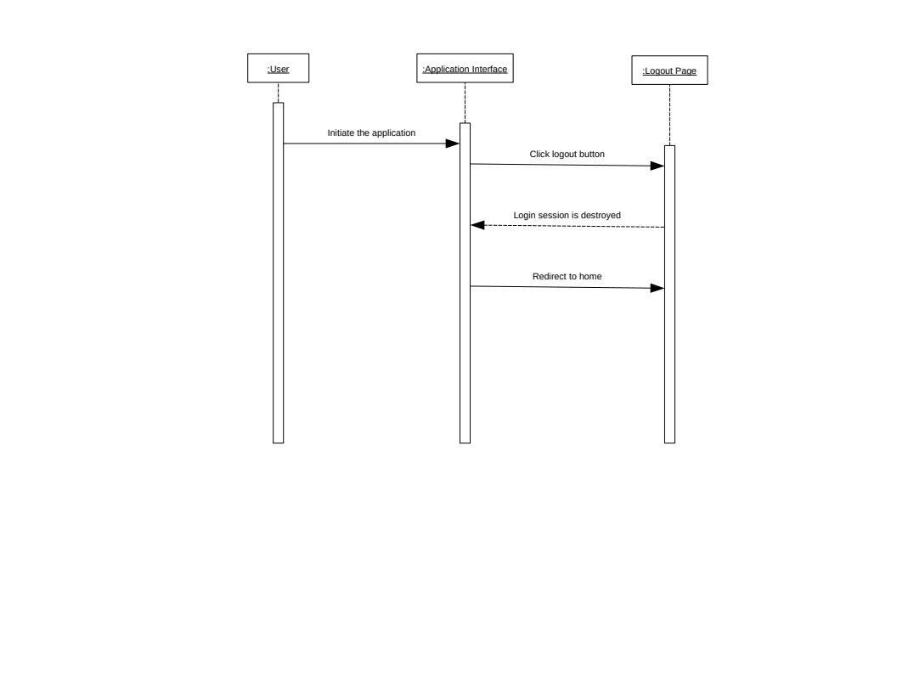Figure 9: Logout - Sequence Diagram

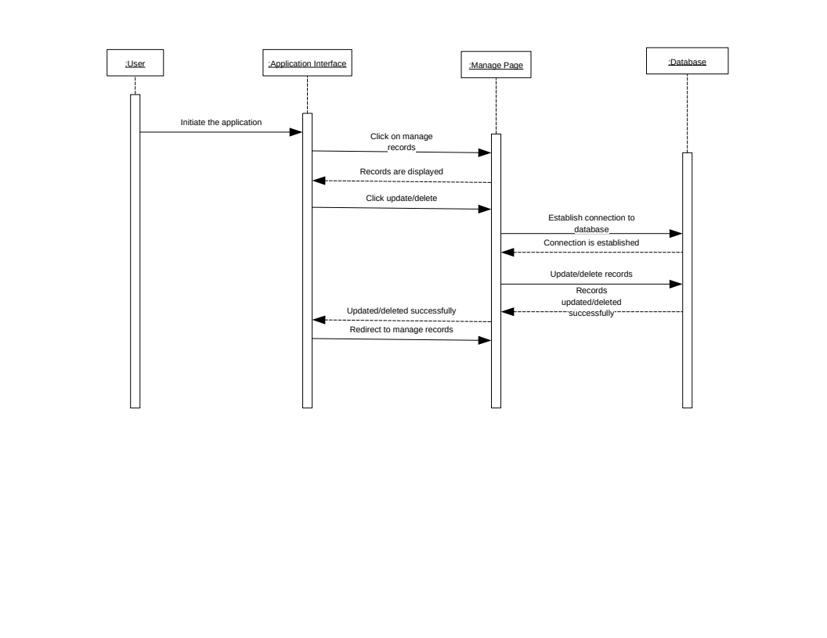Figure 10: Update / Delete Records - Sequence Diagram

- Architecture Design Diagram

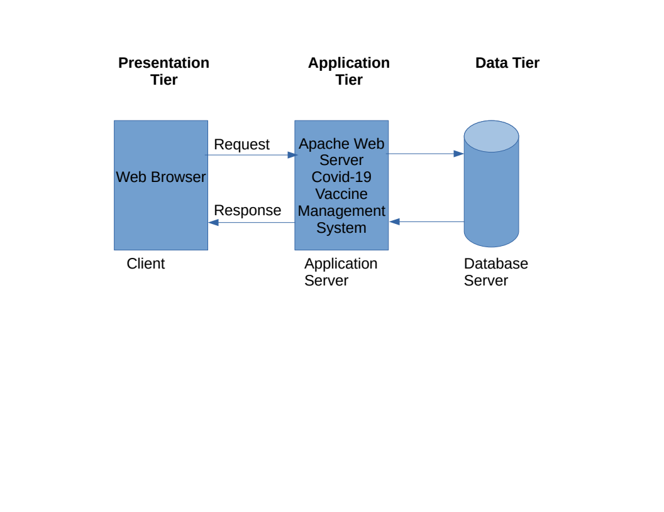

- Class Diagram

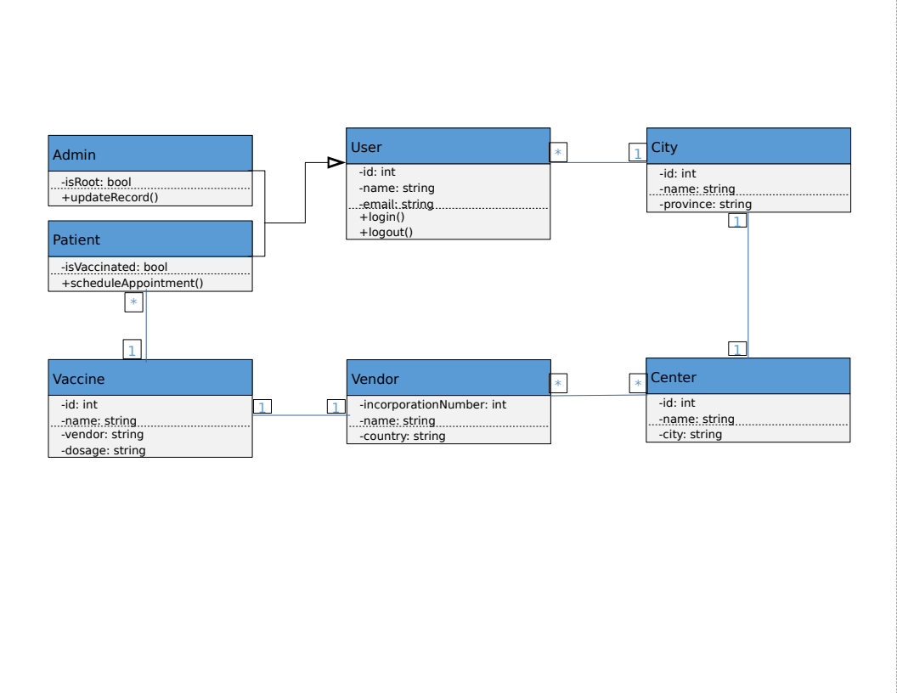

- Database Design

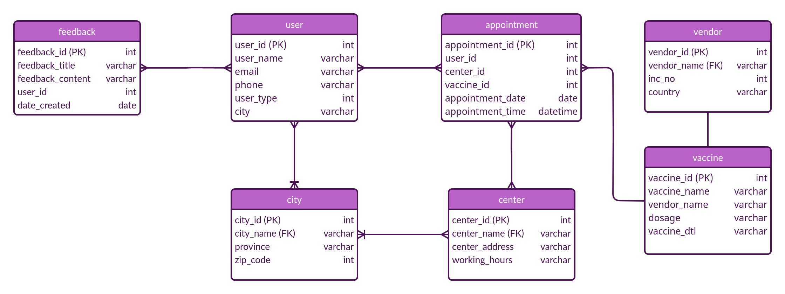

- Interface Design

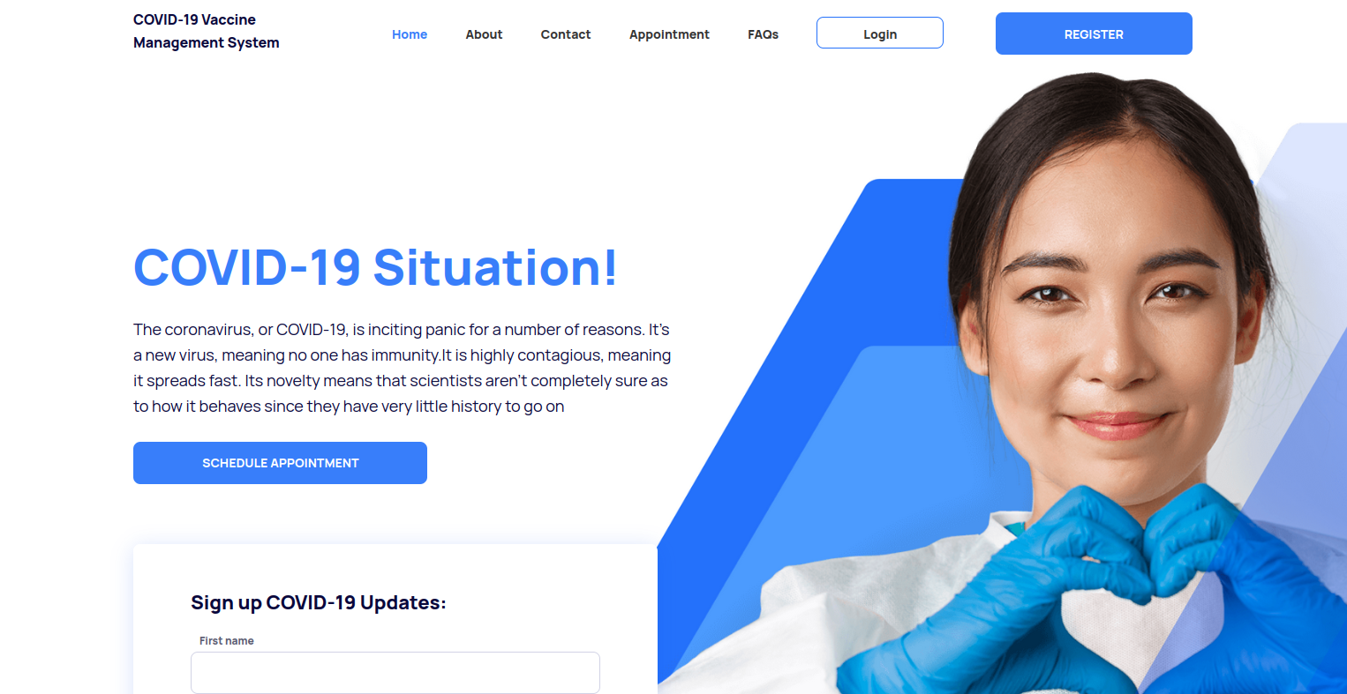Figure 11: Home - COVID-19 Vaccine Management System
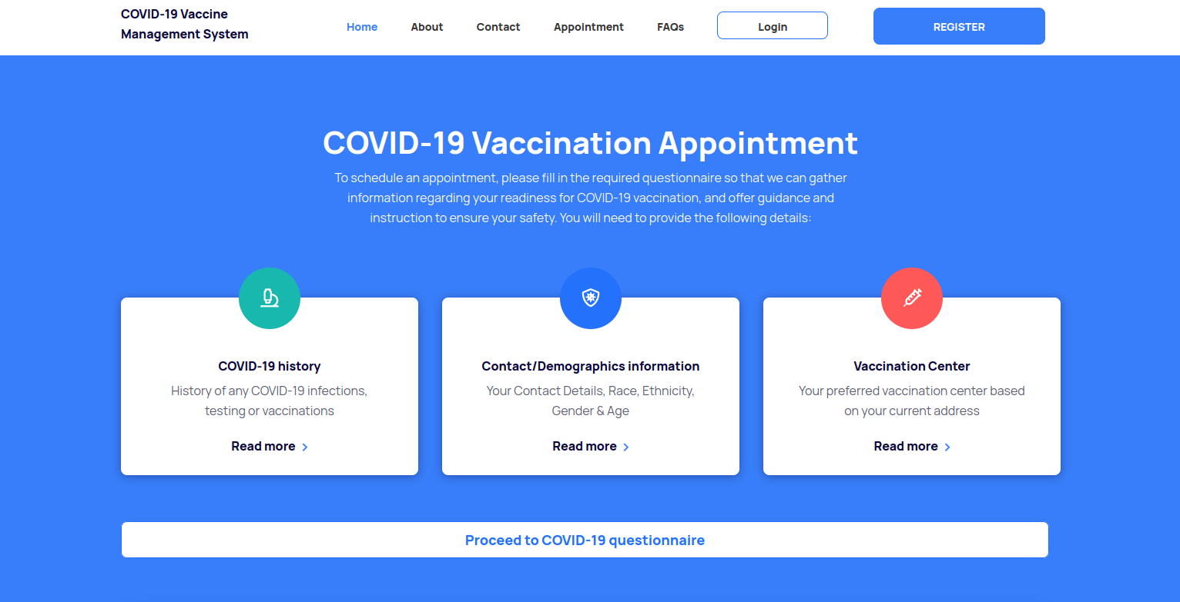Figure 12: Schedule Appointment - COVID-19 Vaccine Management System

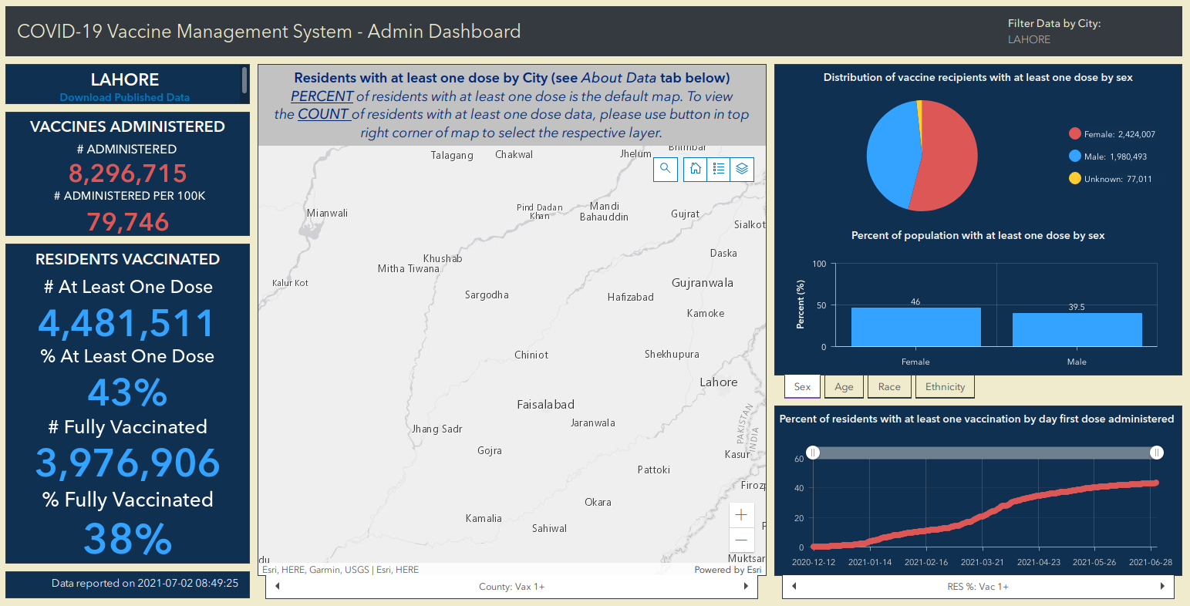Figure 13: Admin Dashboard - Statistics

- Test Cases

Test Case ID | Scenario | Test Steps | Expected Results | Actual Results | Status
TC001 | View Vaccination Centers | - User types in the URL in the browser and get in to homepage  - User sees vaccination centers in navigation and clicks it  - Vaccination centers page opens with all the available vaccination centers  - User can apply filters i.e. city  - On applying filters vaccination centers with filter criteria will be shown  - User can click on a center to view details about center | User finds a suitable vaccination center | As Expected | Pass
TC002 | View Vaccinations | - User types in the URL in the browser and gets to the homepage  - User sees vaccinations in navigation and clicks it  - Vaccinations page opens with all the available vaccinations  - User can click on a vaccination to view details about vaccination | User finds required details about a vaccination | As Expected | Pass
TC003 | View Procedure To Get Vaccinated | - User types in the URL in the browser and get in to homepage  - User sees procedure in navigation and clicks it  - Vaccination procedure page opens with a list of procedures to get vaccinated | User finds complete procedure to get vaccinated | As Expected | Pass
TC004 | User Registration | - User types in the URL in the browser and get in to homepage  - User sees registration in navigation and clicks it  - Registration page opens with a registration form  - User types in details in input fields in the registration form and click register  - A success message is shown to user for registration and a link to login page is shown | User gets registered | As Expected | Pass
TC005 | User Login | - User types in the URL in the browser and get in to homepage  - User sees login in navigation and clicks it  - Login page opens with a login form  - User fill in the form and clicks login to login in to the system | User sessions starts and redirects to dashboard | As Expected | Pass
TC006 | Schedule Appointment | - User types in the URL in the browser and get in to homepage  - User login to the system  - User click Schedule an appointment and gets a page with appointment form  - User selects city, center, and vaccination type to make an appointment and clicks confirm | User gets a successful appointment message | As Expected | Pass
TC007 | Give Feedback | User types in the URL in the browser and get in to homepage  User logins to the system and opens dashboard  There is an option for feedback  After clicking feedback option a page with form will be shown  User types in his message and submits feedback | User gets a successful submission of feedback message | As Expected | Pass
TC008 | Register a Complaint | - User types in the URL in the browser and get in to homepage  - User logins to the system and opens dashboard  - There is an option to register a complaint  - On clicking register a complaint option a form is shown  - User selects appropriate values in fields and types in his message and submits his complaint | User gets a successful complaint submission message | As Expected | Pass
TC009 | User Logout | - User types in the URL in the browser and get in to homepage  - User logins to the system and after being logged in it can click on profile icon  - Profile icon will show an option to logout  - After clicking logout a dialog with confirmation message will be shown  - After confirming user logout of the system | User session gets terminated and redirects to homepage | As Expected | Pass
TC010 | Administrator Registration | - Admin logins to system as admin privileges  - Admin opens its dashboard and there is an option to manage administrators  - On clicking manage administrator admin can open an option to add administrator  - Admin needs to provide user name to make administrator  - On clicking add it will confirm password and administrator will be added in the system | Success message for admin added is displayed | As Expected | Pass
TC011 | Cancel An Appointment | - Admin logins to the system with admin privileges  - After loading admin dashboard admin can view all appointments  - Admin can select any appointment from the list and can click cancel button  - After clicking cancel a confirmation dialog will be opened  - On confirming the appointment gets canceled | Information message for appointment cancellation is displayed | As Expected | Pass
TC012 | Manage Records | - Admin logins to the system and opens dashboard  - Admin can open any link from navigation i.e. Vaccination centers, vaccination categories, cities, appointments  - Admin can view any data from these categories after clicking  - Admin can open any record from these categories and can click buttons to edit or delete any record | Information message for record inserted, updated or deleted is displayed | As Expected | Pass

